8.37: Let +y be north and +x be south. Let 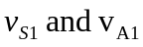 be the speeds of Sam and of Abigail before the collision.
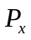 is constant gives
